# Required Components

|  |  |  |
| --- | --- | --- |
| **BOM** | | |
| 1x Mouthpiece Holder | 3x Neodymium magnets | 1x Magnet cover | |
| bottom view of mouthpiece holder | 3 neodymium magnets | bottom view of magnet cover |

# Assembly Instructions

## Step 1

Insert magnets in the back of the holder.

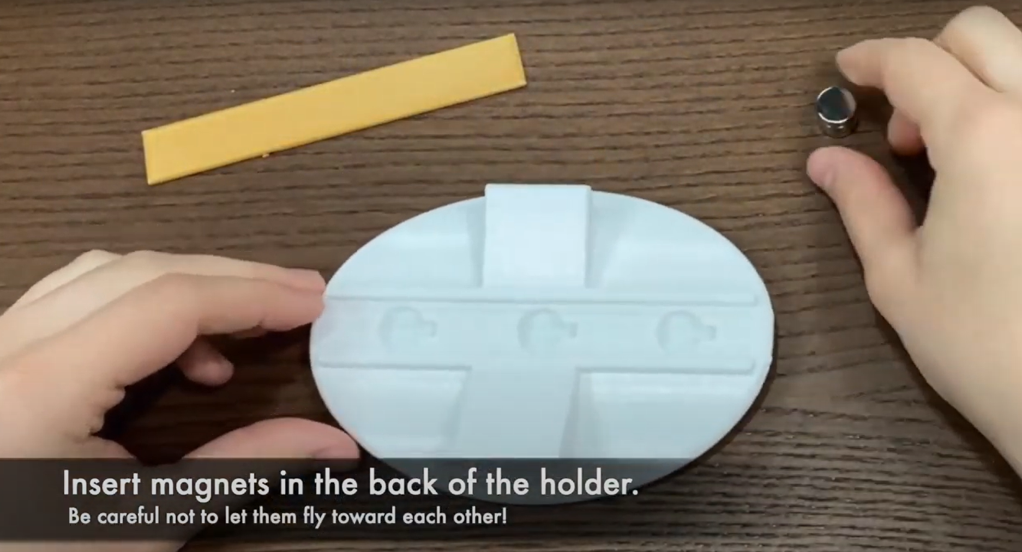

## Step 2

Insert magnet cover in the slot over the magnets.

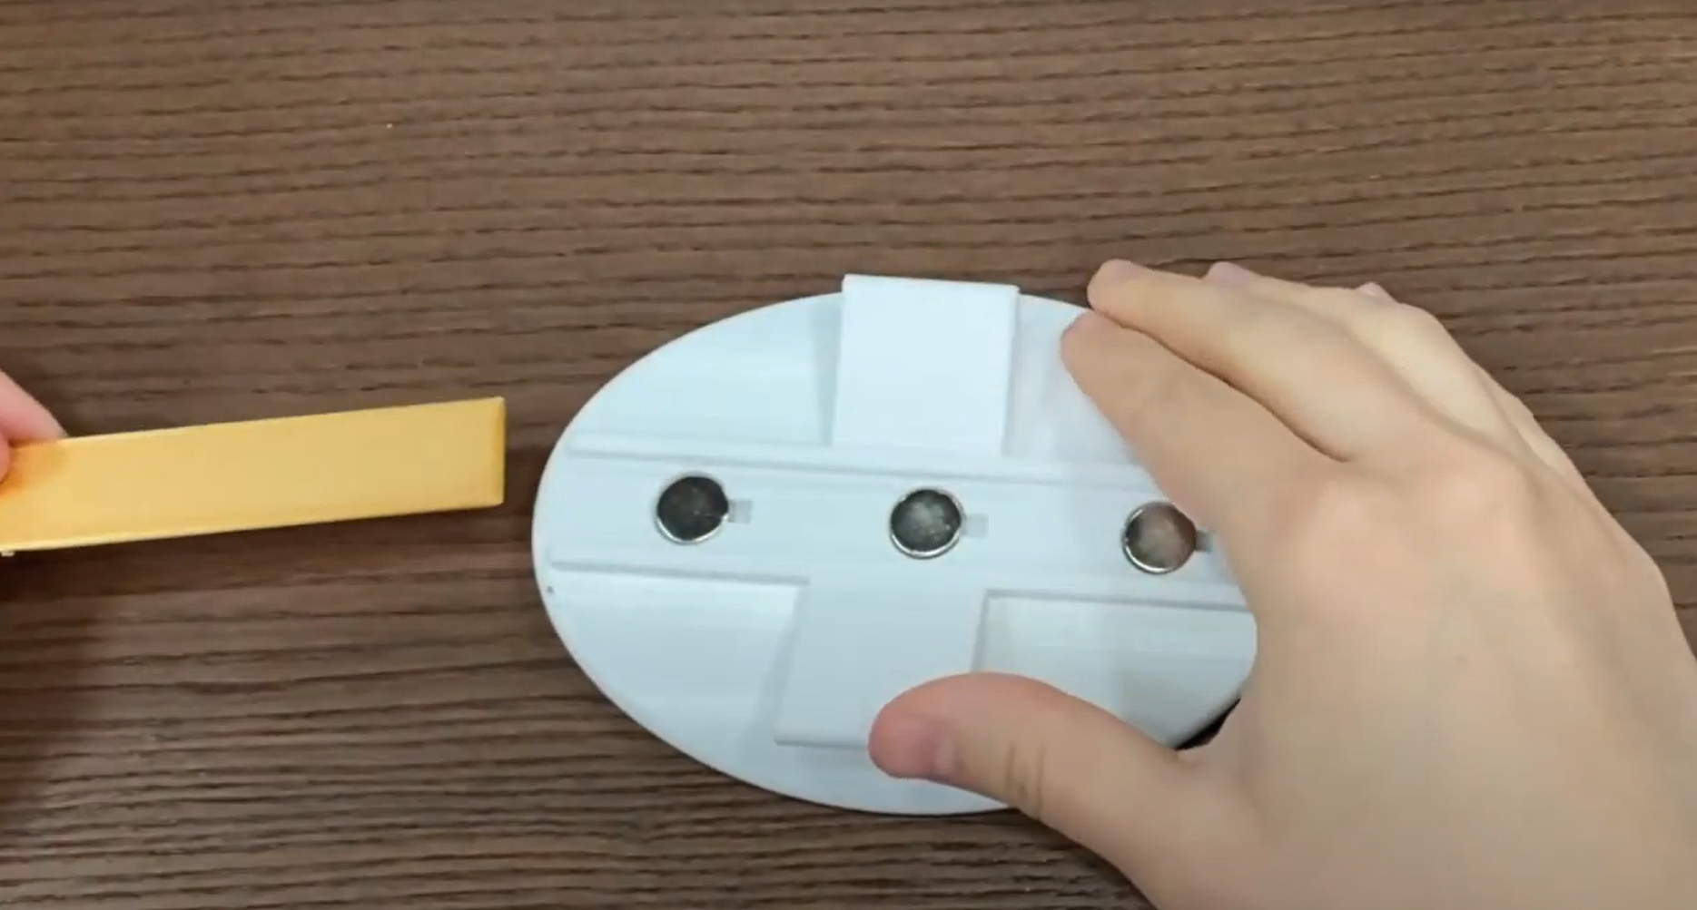

## Step 3

Mount the holder within the grips on a phone mount.

